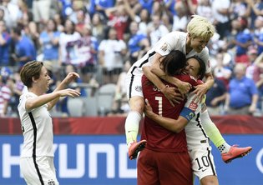

1. Five top players on the phenomenal United States women’s soccer team filed a federal complaint last week alleging _________.
- corruption among FIFA officials
- discrimination based on being forced to play on artificial turf
- pay discrimination
- sexual harassment by one of their coaches

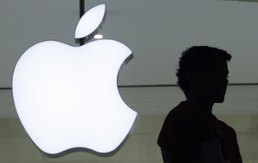
Mark Lennihan/Associated Press

2. A furious legal battle over digital privacy in the age of the iPhone ended last week with no clear winner — only lingering questions over what will happen the next time _________ to force Apple to help break into one of its own phones.
- consumer groups try
- rival technology giants want
- the government tries
- workers’ unions attempt

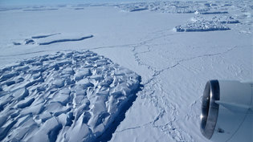
Jim Yungel/NASA

3. New research suggests that the West Antarctic ice sheet, which is larger than Mexico, could disintegrate within decades, heaving enough water into the ocean to raise the sea level as much as three feet by _________.
- 2020
- 2025
- the end of this century
- the next millennium
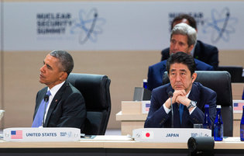
Doug Mills/The New York Times

4. At a summit devoted to the issue on April 1, President Obama questioned Donald J. Trump’s fitness for office after statements from the Republican front-runner that the United States and its allies should move away from decades of constraints on _________. “We don’t want somebody in the Oval Office who doesn’t recognize how important that is,” Mr. Obama said.
- immigration
- the role of NATO and the United Nations
- the use of nuclear weapons
- women’s reproductive rights
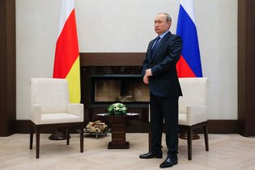
Maxim Shemetov/Agence France-Presse — Getty Images

5. What are the “Panama Papers” and why are they in the news?
- 11.5 million leaked documents from a Panama law firm that helped some of the world’s wealthiest people establish offshore bank accounts.
- An insider’s account of how bribes, graft and cover-ups have led to a crisis in Brazil.
- A leaked version of a secret government study of the Vietnam War.
- Leaked scientific reports on Panama’s first case of birth defects associated with the Zika virus.
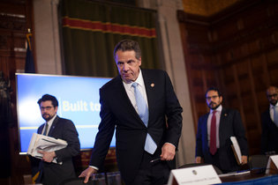
Nathaniel Brooks for The New York Times

6. Last week, New York and California became the first states to sign legislation to _________.
- allow students to carry concealed handguns on college campuses
- eliminate anti-discrimination protections for lesbian, gay, bisexual and transgender people
- push the minimum wage to $15 an hour
- shut down all Planned Parenthood clinics
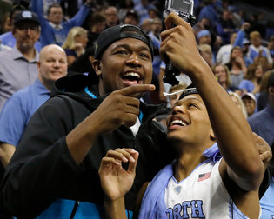
Matt Rourke/Associated Press

7. All of the following happened in sports this week, EXCEPT:
- Baseball season began with the first major league games.
- Seattle Slew won the 142nd Kentucky Derby.
- Villanova beat North Carolina to win the N.C.A.A. men’s basketball championship.
- Yao Ming, Allen Iverson and Shaquille O’Neal were chosen for the Basketball Hall of Fame.
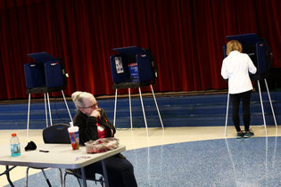
Travis Dove for The New York Times

8. The Supreme Court on April 4 unanimously ruled that states may count all residents, whether or not they are eligible to vote, in _________. The decision was a major statement on the meaning of a fundamental principle of the American political system, that of “one person one vote.”
- census-taking
- creating superdelegates
- drawing election districts
- Electoral College math
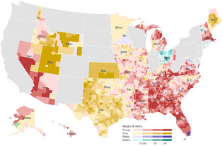

9. The primary season is in high gear this week with voting on April 5 in Wisconsin, where __________ are positioned to win. This is the first of several important contests this month.
- Donald Trump and Hillary Clinton
- Hillary Clinton and Bernie Sanders
- Ted Cruz and Bernie Sanders
- Ted Cruz and Donald Trump

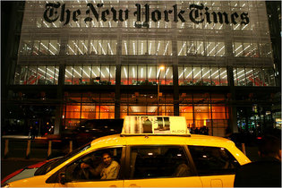
Richard Perry/The New York Times

10. Three of the news items below about new products and inventions appeared in The Times in the last week. One is from the satirical paper The Onion. Which is the fake news story?
- Mattel Releases New Male Barbie to Inspire Girls to Imagine Holding Highest Leadership Positions
- Tesla Model 3 Orders Surge Even Before Its Unveiling
- The R70i Age Suit Lets You Experience What It’s Like to Be Old
- Whoopi Goldberg Joins Marijuana Industry With Products for Women

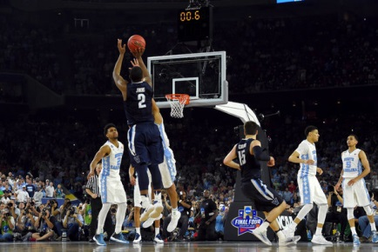
Above is a photograph related to one of the news stories we have followed recently. Do you know what it shows?Credit Bob Donnan/USA Today Sports, via Reuters
From “Ball Flies. Horn Blares. Villanova Reigns,” the caption reads, “Villanova’s Kris Jenkins shooting the game-winning 3-pointer over North Carolina’s Isaiah Hicks. “I think every shot is going in,” Jenkins said afterward.

