Write a response to Jonathan Edwards’ sermon from the point of view of one or more members of his congregation. You might write your response as a letter, or as a dialogue between two of the listeners. Be sure to cite at least 3 specific lines from the sermon. Your letter should be at least 1 page long.
As much as you want to react personally, remember that this assignment is to imagine yourself in the position of one of the Puritans in Edwards’ congregation. Consider how his contemporaries might have reacted to Edward’s sermon. Would they have approved? Which lines are particularly memorable, and why?
Before you begin writing, decide whether you (or your speaker/writer) will have a negative, neutral, or positive attitude. These tone words will help you brainstorm:
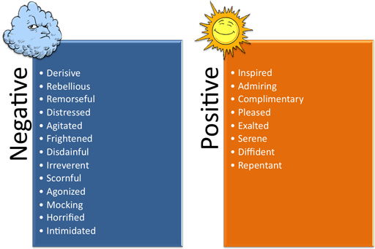
Letter format
-include greeting, date, separate paragraphs, closing, signature
OR
Dialogue/Script format
-imagine and draft a conversation between Edwards and a member of the congregation or 2 members of the congregation about the sermon he delivered

