Article Format Name _________________________
October Issue of The Talon

Please follow these guidelines when typing your FINAL DRAFT:

Headline:
- 3-6 words – Ask for permission before submitting a sub-headline.
- Capitalize all words except prepositions
- Calibri - size 18
- Left justified – NO CENTERING!

Byline:
- Reporter’s First and Last Name on first line
- No nicknames
- Calibri - Size 11 - Bold
- Staff Position on second line
- Unless you have a position on the Editor Staff, your title is Staff Reporter.
- Calibri – Size 11 – Italics

Article:
- Left justified
- Indent each paragraph using the TAB key – must be multi-paragraph
- Calibri – Size 11 - regular
- Single-spaced, no spaces between paragraphs
- Double check the spelling of all proper names
- 300-400 words unless approved by Mrs. Clay or the Co-Editors-in-Chief

Photo Caption:
- Write a sentence with an action verb describing what is going on in the picture.
- Aim to identify the major players in the photo by name and grade/title.
- Carefully spell names!
- Calibri – Size 10 - regular

Photo Credit:
- Calibri – Size 10 – italics
- Carefully spell the photographer’s name
- If you find a photo on the internet, search HARD for a photo credit. If you cannot find one, give credit to the website.
- You as a reporter (and we as a publication) can land in hot water (a.k.a. courtroom) if we violate copyrights. BE CAREFUL!

Dr. Matney – The Man, The Myth, The Eagle

Brittany Niemeyer
Co-Editor-In-Chief

Prior to Landstown, Dr. Matney served as the principal of Frank W. Cox High School for nine years, until 2011 when we welcomed him to Concert Drive with open arms. Imagining where he will be five years from now, Dr. Matney very easily sees himself still at the job he loves: being the principal of Landstown High School for the 9th consecutive year. When asked what makes Landstown the best school in Virginia Beach, without hesitation he answered, “It’s the best group of students I have ever worked with, anywhere. I love the spirit, the enthusiasm, and the diversity of our campus.”
Throughout his career, he has certainly won many accolades! Did you know he was named the 2006 VASSP State High School Principal of the Year and the 2014 VSCA Administrator of the Year? Did you know he was valedictorian of Kempsville High School? Did you know he won scholarships to both UVA and UNC Chapel Hill? So how about the man behind the awards? Dr. Matney is a family
man with one undeniable trait: passion. Even with his impressive list of accomplishments, Dr. Matney stated that his biggest one was marrying the woman of his dreams 22 years ago. Mrs. Matney is an AP chemistry teacher at Tallwood High School, and together they have two sons. Will is a junior at Kempsville High School, and JT is an 8th grader at Kempsville Middle School.
Always smiling and always walking fast, Dr. Matney has an incredible vocabulary and a stellar memory for details. He has a gift for remembering names of other people’s family members, favorite sports teams, and alma maters. While it may be hard to believe, Dr. Matney has a normal life away from school like anyone else. His favorite time of the year is the fall, and nothing can beat a game here at Landstown or catching an NFL game with his sons. When asked about chores, he admitted, “I actually love cutting the grass, but I hate taking out the trash.” If he could change his first name, Dr. Matney said he would choose Augustus. For those of you who do not know, Augustus is the middle name of our Student Activities Coordinator, Mr. Siock. Dr. Matney was both eager and excited to share that interesting fact.
Whether it’s being an administrator, a husband, a father, or a teacher, it is crystal clear that he is in love with what he does, especially being an Eagle. (411 words, article only)

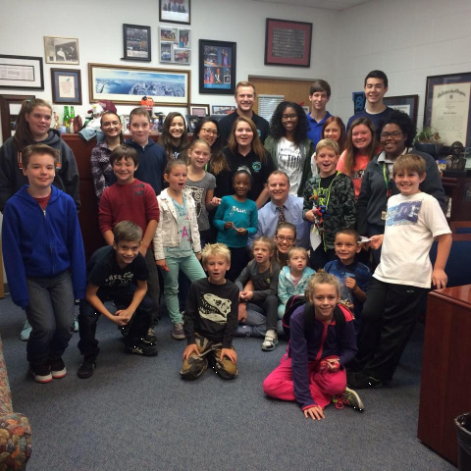
Dr. Matney welcomes the faculty’s children (and the VTfT students supervising them) into his office on the November Staff day.
Photo Credit: Deborah French

