Elements of a Newspaper
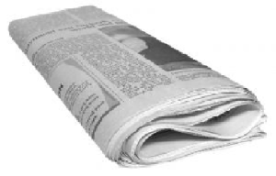# Banner: Banner is a headline that runs across all eight columns on the top of the page. It is used for momentous events, and is set in big and bold letters. The banner is also called a streamer.
# Byline: The name of the reporter who wrote the story. In the case of agencies, the name of the news agency is used as byline.
# Caption/Cutline: The text used to describe a photograph.
# Column: Each newspaper page is divided into six to eight vertical rows. These rows, which are used to display content, are called columns.
# Double-truck: a spread in the center of a newspaper, printed as one sheet of paper.
# Folio: Folio is the line of text placed on top of inside pages giving the page number, day and date of publication.
# Headline: Headline is the title of a news report run in display type to catch the attention of the readers. A headline summarizes the most important point in a news report.
# Infographic: An infographic is an art form where words are used with charts, illustrations, graphs or photographs to tell a news story.
# Lead: Lead is the first paragraph of a news report.
# Masthead: Masthead is the forehead of the newspaper where the title of the newspaper is published. It also gives the place of publication, publication date, etc.
# Photo credit: identifies the photographer of an individual photo.
# Pull quote: a quote taken from a story and used as a graphic to pull in the reader.
# Teaser: Teaser is a front-page box announcing a paper’s inside contents.

