“Movie Review” Romeo and Juliet by Baz Lurhmann
A Powerpoint Presentation
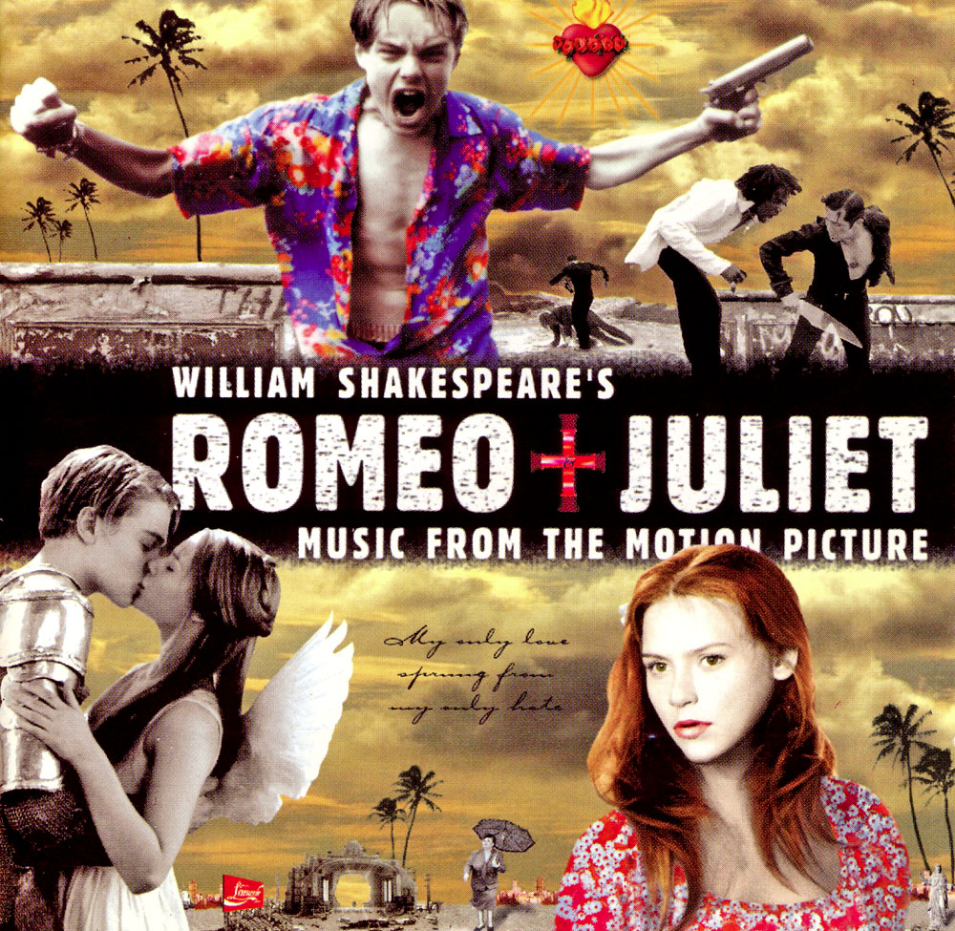
Page Layout | Content
Title Page | Name of Movie  Director, year  Student Name(s), Class, Period
Title, Text and image | List Four Main Characters and the stars who played the roles
Title, Clip art, and Text (Main characters) | 1 slide per main character (name of character in heading)  Photo of main character AND description of the role they played (character analysis)
Title, Clip art, and Text  (Summary) | Synopsis (summary) of the movie in 3 - 4 slides that tells the story of the movie. Example: 1st slide = To begin, … 2nd slide = Next, … 3rd slide = And then, … 4th slide = Finally, ….
4 recurrent images/symbols | Explanation as to why you chose these images to present using concrete details and examples
Important scene (could be linked to a video) or image | Describe the cinematography. Give a specific analysis of the filmmaker's techniques (camera angles, framing, close ups, lighting, special FX

Guidelines – Include each element below:

- All 12 slides (or more) completed
- Animated text and/or clip art
- Followed slide layout requested
- Used self-created backgrounds or design template
- Used at least ONE background picture on at least one slide
- Demonstrated correct grammar, punctuation and spelling
- Timed the presentation to run without mouse click
- Timed so audience could read all information on the slides
- Title came first on each slide
- Appropriate background music played throughout presentation
- Link to a video (or downloaded video) of the scene you chose (try to limit to 3-5 mins)

Romeo and Juliet Film Review Rubric
Criteria | Level 4 (80-100) | Level 3 (70-79) | Level 2 (60-69) | Level 1 (50-59) | Re-do (0-49)
Knowledge – Demonstrates an understanding of the film’s social, and / or cultural context. | Demonstrates a thorough, detailed, and insightful understanding of the social, and / or cultural context. | Demonstrates a clear and sufficient understanding of the social, and / or cultural context. | Demonstrates some understanding of the political, economic, social, and / or cultural context. | Demonstrates a limited understanding of the social, and / or cultural context. | Demonstrates an insufficient or inaccurate understanding of the social, and / or cultural context.
Thinking – Evidence of relevant and useful research; appropriate selection of examples from the movie. | Evidence of thorough and detailed relevant and useful research; insightful selection of examples from the movie. | Sufficient evidence of relevant and useful research; clear selection of examples from the movie. | Some evidence of relevant and useful research; fair selection of examples from the movie. | Limited evidence of relevant and useful research; questionable selection of examples from the movie. | Lacking evidence of relevant and useful research; inappropriate selection of examples from the movie.
Communication – The film review is structured and organized clearly presented in a way that enhances the overall meaning | The film review is very well structured and organized in a way that clearly enhances and reinforces the overall meaning. | The film review is structured and organized in a way that sufficiently enhances the overall meaning. | The film review has some structure and organization that somewhat enhances the overall meaning. | The film review has limited structure and organization but does not enhance the overall meaning | The film review is structured and organized poorly in a way that detracts from the overall meaning.
Application –Demonstrates clear and persuasive interpretation and analysis of the film’s central ideas and techniques. | Demonstrates insightful and persuasive interpretation and analysis of the film’s central ideas and techniques. | Demonstrates clear and sufficient interpretation and analysis of the film’s central ideas and techniques. | Demonstrates some interpretation and analysis of the film’s central ideas and techniques. | Demonstrates limited interpretation and analysis of the film’s central ideas and techniques. | Does not demonstrate any interpretation or analysis of the film’s central ideas and techniques..

