Quiz – Into the Wild – Chapter 16
1. How did Chris travel 1,000 miles from Laird, Alaska to Fairbanks?
a) Jim Gallien gives him a lift.
b) Gaylord Stuckey picks him up.
c) Since it is so remote, he walks most of the way.
d) Hitchhiking. He gets a series of rides from mostly friendly truck drivers.
2. What two requests does the truck driver make of Chris/Alex as they part company?
a) change his mind and go back to Wayne
b) wait until spring and work to get money for better boots
c) write him a letter when he returns and call his parents before he goes into the wilderness
d) send him photos of his adventure and notify the forest service where he will be
3. When he sets off on the Stampede Trail, what food and supplies did McCandless have with him? Circle ALL that apply.
a used gun 4 boxes of rifle shells backpack
tent fake-fur parka matches
“bug dope” bag of rice fishing rod
journal paperback books detailed map canteen flask of whiskey of Alaska

4. How far does Chris travel on the Stampede Trail before he locates the abandoned bus?
a) six miles
b) just under eleven miles
c) about twenty miles
d) two-and-a-half days of walking
5. Why does Chris write in his journal that he had found “The Magic Bus?”
a) it saved him from having to pitch his tent
b) it was stocked with wilderness essentials by the hunters who use it during hunting season
c) it reminded him of a magic flying machine
d) it popped up out of nowhere
6. What surprising difficulties did he NOT have during his first week – despite finding the bus?
a) he saw but did not shoot a grizzly bear
b) he shot at but missed some ducks
c) he was snowed in
d) he was feverish and experienced flu-like symptoms

Name __________________________________

7. When the snow melted, what did McCandless gather and eat?

________________________________ and

_______________________berries
8. Once McCandless could hunt well, what animals did he kill and eat?
spruce grouse, duck, goose, ________________
and ___________________________
9. Explain why Chris McCandless says that shooting the moose was one of the “greatest tragedies of my life.”

10. In July 1992, Chris packed his belongings and left the Magic Bus, presumably to return to society. What happened that caused him to return to the bus two days after he left?
a) he fell into the still-freezing water of the Sushana River and was fighting hypothermia
b) he lost his balance when crossing the rocky pass through Denali and twisted his ankle
c) he was lost and couldn’t find his way back to the Stampede Trail
d) he couldn’t cross the rushing water of the Teklanika River

Bonus Questions: (1 point each)

1. If McCandless had walked a mile or so upstream, he would have discovered that…

2. Finish Stuckey’s thought “…‘Oh, why didn’t I get his…”

Who's Who?
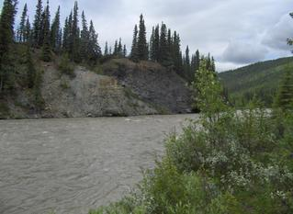
Character One's Name: Christopher McCandless
Description:
. Anti-social
. 22 Years Old
. Cleanly shaven most of the time, he carried a disposable razor on his journey and he used it to take a nice shaven photo of himself infront of the bus.
. Bearded, chapter 18. Short Hair, pg 158
. Courteous
. Sunken Cheeks, pg 169
Characteristics with Justification
. Good company to have around – pg 159
Stuckey told Chris he would drive him only to White Horse, but after spending a few days with him he realized that he was so interesting that he wanted to drive him the whole way.
. Stubborn – pg 161
Chris wouldn't give Stuckey a straight answer after he asked him to call his parents and let them know where he is. Chris refused to listen because it would interfere with his plans.
. Poor Planner – pg 170-171
He decided not to cross the Teklanika River because it looked to over flowed and he assumed that it would knock him off his feet and he would come down with hypothermia. But, if he had brought a map he could have found a safe way across the river and in the end, he could have lived.
Character Two's Name: Gaylord Stuckey
Description:
. Bald
. Cheerful
. Ham faced
. 63 Years Old
. Hoosier (all found on pg 158)
Characteristics with Justification:
Kind Hearted: pg 158-159
He knew that his job prohibited picking up hitch hikers but he knew that Chris was a good guy and that he was not just a typical hitch hiker.
Caring: pg 159
He begged Chris to call his parents because he knew what it must have felt like to not know where you child is, and he was just thinking of his parents feelings. Stuckey also knew that Chris needed food and he took him to the grocery store and bought him a large bag of rice.

Where in the world?
During chapters 16-18 Chris is in Alaska near the Teklanika River. He slept in the bus and hunted near the river.

Chapter Summary
. Chris is at a campground at the Liard River and he meets Gaylord Stuckey.
. Stuckey is dropping and RV to the Fairbanks and decides to drive Chris there with him.
. Three days later they arrive and Stuckey buys Chris a big bag of rice.
. Chris bought a used gun (Semiautomatic .22 caliber).
. Chris reaches the Teklanika River two days after venturing out.
. On April 29th Chris fell through the ice.
. On June 9th Chris killed a Moose, but he failed to preserve the meat and it became infested with maggots and flies, so he had to get rid of the meat.
. On July 5th Chris tired to cross the Teklanika River but it was flooded and he decided to go back to the bus.
. Krakauer says that if Chris had taken a map and traveled up stream he would have able to cross safely.
. Krakauer revisits Chris's bus and talks about his possessions that he left.
. Krakauer talks about Chris and how he lacked common sense and how his mistakes had cost him his life.
. The Last book he read was called Doctor Zhivago, and a very important and significant quote he wrote in his journal said “Happiness only real when Shared.” I think this is the point where he realizes that this whole journey he did is a huge mistake and that he figures out that he had isolated himself from the people who loved him.
. Krakauer concludes that Chris must have confused a poisonous plant with an edible plant that caused him to become very sick. The plant prohibited him eating, which caused him to starve to death.
. Christopher McCandless spent a total of 112 days in the wild, and sadly he died on august 18th.

So what?
The reader can learn that you should always be prepared and that it is foolish to venture out into the wild. Especially without a map, and proper equipment/supplies. When Chris attempted to cross the river and than decided not to because he assumed that the river was to dangerous proves that he was unprepared. If he had brought a map he could have found a safe way across and he would have been alive to this day. So, the reader learns that it is always important to use common sense and be prepared.

Trivia Time
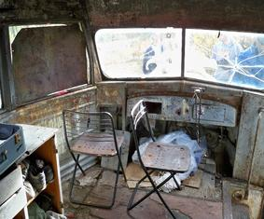
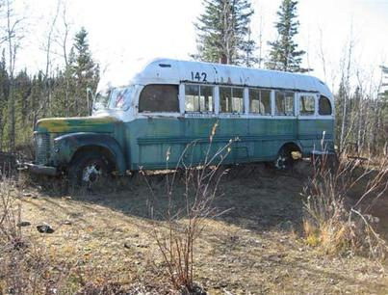
True or False?
Christopher tried to cross the Telantika River but decided it was too dangerous so he headed back to the bus.
A: False, Christopher tried to cross the Teklanika River.
How did Chris die?
A: He confused a poisonous plant with an edible plant
True or False?
Chris killed a Caribou, but than it became infested with maggots, so he was forced to throw away the meat.
A: False, Chris killed a Moose, not a caribou.
What did Chris name the day that he found the bus?
A: “The Magic Bus Day”
What day did Chris die?
A: Chris died on August 18th

Sources
Krakauer, Jon. Into the Wild. New York: Anchor Books, 1997.

