She Does It All
She's a talk show host, publisher, actor, businesswoman, and household name-but Oprah Winfrey came from humble beginnings. Born in rural Mississippi, Oprah was an excellent student who won a college scholarship. At age 19, while still a student, she became the first female African-American to anchor the news on a local television station. In 1984, Winfrey became the host of a talk show called AM Chicago, but Oprah herself became so popular that the show was quickly named after her. In 1986, the show began airing around the nation, and that same year, Winfrey formed her own production company, Harpo. The Oprah Winfrey Show is the number one talk show and has won numerous awards, as has its host. Oprah is known for her sense of compassion and her ability to connect with the viewers at a very familiar level, despite her own enormous wealth. In fact, she has used her show to publicize and encourage philanthropy. But talking isn't all Oprah does. She has also appeared in several movies, including The Color Purple, for which she was nominated for an Oscar. Five years ago, Winfrey launched her own magazine, O: The Oprah Magazine. It seems that everything Oprah touches turns to gold!
Oprah’s Adventure
On September 8, 1986, The Oprah Winfrey Show made its debut on national television. The host, Oprah Winfrey, was a little-known journalist and aspiring actress. Twenty-five years later, Winfrey was arguably one of the most powerful people in the world. She was so famous and so familiar that fans and critics referred to her simply as "Oprah." When the last Oprah Winfrey Show aired, Oprah had left her mark—not only as a television personality, but also as a force in entertainment.
The finale of Oprah Winfrey's talk show, which aired on May 25, 2011, was uncomplicated. Many of the elements fans had come to associate with the show, such as free cars, makeovers, giveaways of Oprah's "favorite things," and celebrity guests, were absent—what remained was her connection with viewers. Oprah stood on an empty stage and spoke to the audience, saying that she knew what the show had meant to viewers, and emphasizing that the show had meant a great deal to her.
"Something in me connected with each of you in a way that allowed me to see myself in you and you in me," Winfrey told her fans, adding, "I listened and grew, and I know you grew along with me."
"It is no coincidence that I grew up to feel a genuine kindness, affection, [and] trust... from millions of you all over the world," Oprah said, telling viewers that sometimes she was a teacher, but more often her viewers instructed her.
It was the end of one chapter in Oprah Winfrey's life, and it served as a reminder of how far she had come. Born January 29, 1954, in Kosciusko, Mississippi, Oprah lived with her grandmother during her early childhood. Oprah's grandmother was impoverished but encouraged a bright future for her granddaughter—Oprah learned to read at age 3 and realized at an early age that she had a gift for public speaking. When Oprah was 6, she and her mother moved to Milwaukee, where family life became fraught with difficulties. Oprah had a troubled childhood and early adolescence, but she found hope again as a teenager, when she moved to Tennessee to live with her father. Strict but supportive, Vernon Winfrey encouraged Oprah to work hard in school.
When Oprah was still in high school, she landed a job in radio, and soon after, her talent for public speaking helped her win a scholarship to Tennessee State University. Years later, Oprah would often recall what access to education meant to her, and she would devote a substantial amount of her fortune to helping others attend college. During her time at Tennessee State, Oprah got a job as a local news anchor, feeling that she was destined to work in television news.
However, Oprah eventually learned that she had another gift: an ability to connect emotionally with people, something she could not do by reading the news. In 1984, she took an opportunity to become the new host of a struggling talk show called A.M. Chicago in Chicago, Illinois. A year later, the program was doing well and was renamed The Oprah Winfrey Show. One year after that, it began airing nationally.
Audiences across the country soon got to know Oprah as she interviewed celebrities, invited advice from various experts, and spoke to ordinary people about their struggles. She also revealed some of the mistakes and hardships in her own life, which helped her to resonate with viewers. Even as her fans admired her, they felt that she was just one of them—a human being, whose life was filled with ups and downs.
Fans stayed with Oprah as she tried new things. She acted in a few movies, even earning an Academy Award nomination for her performance in The Color Purple. She started a television and film production company called Harpo Productions and launched O Magazine. By the 1990s, the talk-show host, actress, and businesswoman was one of the wealthiest and most admired celebrities in the country. She was also one of the most generous, giving money to fight poverty and boost educational opportunities.
During the 25 years of The Oprah Winfrey Show, Oprah kept her show, as well as Harpo Studios, in Chicago. Chicago residents say they're grateful for the effect Oprah had on the city's West Loop neighborhood, where Harpo Studios has been located since 1990. Oprah is often given credit for transforming the once-gritty industrial enclave into a neighborhood filled with families pushing strollers and walking dogs. She also brought important people to Chicago, from politicians to actors to musicians. Everyone in the U.S. knew about Chicago before Oprah, but now, Chicago is known to people around the world.
"She's a wonderful citizen of our city," said Chicago Mayor Richard Daley, adding, "We're very proud of [Oprah] and proud of her contribution."
Now, Oprah has moved to Los Angeles, California, where her new cable television station, the Oprah Winfrey Network (OWN), launched on January 1, 2011. She will never lose her love for Chicago, she said, but she is anticipating the future and pursuing new dreams. Art Smith, who once worked as Oprah's personal chef, said Oprah would be loved wherever she went.
"Even though Chicago claims Oprah and loves Oprah, the whole country claims Oprah and loves Oprah because [she] is the great American dream," Smith said.
A timeline shows events in the order that they occurred within a particular period of time. The timeline below shows some events during the life of Oprah Winfrey:
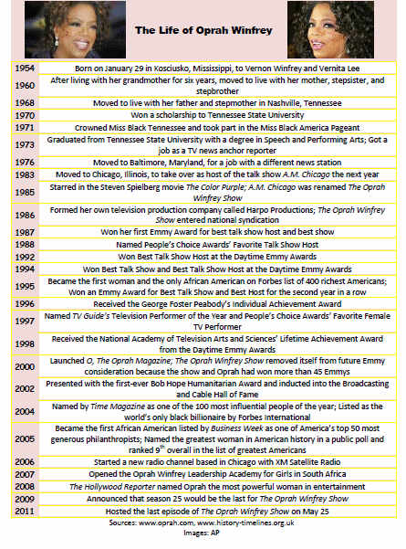

Oprah Opens a New School
HENLEY-ON-KLIP, South Africa (Achieve3000, January 3, 2007). Oprah Winfrey has opened a school for disadvantaged girls. Winfrey says she hopes that the new school will give its students a better future.
The Oprah Winfrey Leadership Academy for Girls, which opened on January 2, is located in the small town of Henley-on-Klip, in South Africa. The $40 million dollar 28-building campus has computer and science labs, a library, a theater, and a wellness center. To qualify for the school, applicants had to show both academic and leadership potential, and had to have a household income of no more than $787 a month. Since the school's 152 students are all from impoverished families, they would not likely have had a chance at a good education without Winfrey's school. Often, poor families cannot afford private schools, and many of South Africa's government-funded schools are overcrowded and devoid of essential school materials, such as books. Violence and drugs can make it difficult for students to concentrate on their studies.
Winfrey says that she decided to open a school in Africa after a conversation with former South African President Nelson Mandela in the year 2000. Mandela spent years fighting against apartheid, a system that oppressed black South Africans and robbed them of the opportunities that they needed to escape poverty. Apartheid was so firmly established in South African society that today, 13 years after it ended, black families continue to struggle. Winfrey, who says that education enabled her to escape poverty, wants to give others the chance to fulfill their aspirations.
"I was a poor girl who grew up with my grandmother, like so many of these girls, with no water and electricity," said Winfrey. The talk-show host plans to build a school for boys in another area of South Africa, and the girls' academy has plans to eventually accommodate 450 girls. Winfrey believes that the schools can produce future leaders who can help reduce poverty in Africa and around the world.
"The best way to effect change long term is to . . . give children exposure and opportunity and nurture them to understand their own power and possibility," she explained.
Winfrey attended the opening ceremony for the girls' school, along with singers Tina Turner and Mary J. Blige, actors Sydney Poitier and Chris Tucker, and director Spike Lee. Each guest brought a personally signed book for the academy's library. President Mandela spoke at the ceremony.
"It is my hope that this school will become the dream of [all] South African [girls] and they will study hard and qualify for the school one day," said Mandela.
Lesego Tlhabanyane, 13, was one of those who qualified and is now attending the school.
"I would have had a completely different life if this hadn't happened to me," she said. "Now I get a life where I get to be treated like a movie star."

