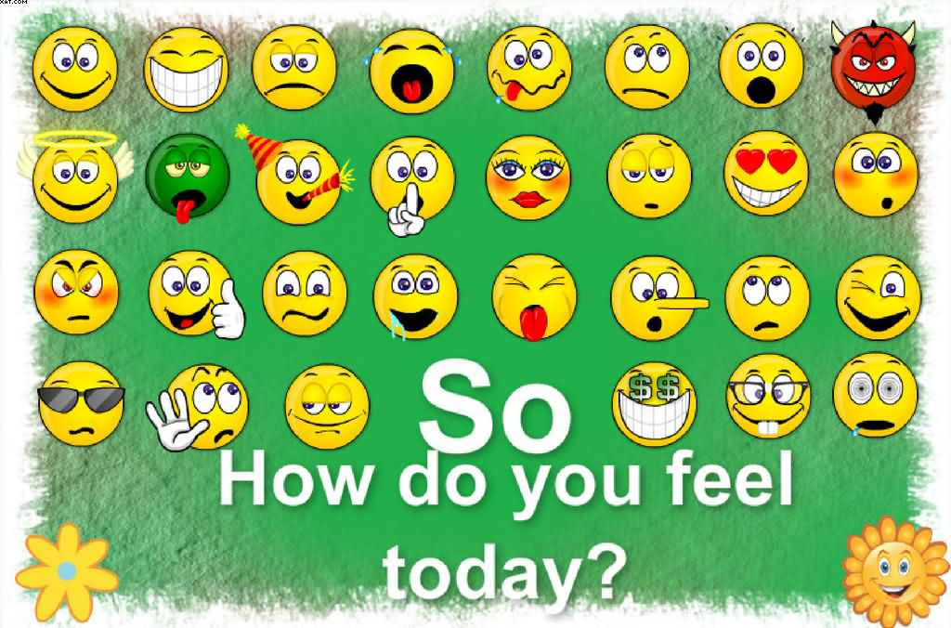

Which of the emojis above represents how you are feeling now?

Which one represents how you were feeling this morning
when you started your SOL Writing test?

How confident do you feel in your writing performance today? If you were to predict your score, would it be Pass Advanced or Pass Proficient?

What did you (or we) do that helped you the most in preparing for today’s test?

What, if anything, would you have done differently if you could do it all over again?

